WS 2025/26

Lab course: Human Robot Interaction

Task 3: Cooperative Lifting

Chair of Autonomous Systems and Mechatronics
Friedrich-Alexander-Universität Erlangen-Nürnberg

TEAM 1 :
Velayudhan Aravindakshan - ju08rufe
Akhilan David Karthikeyan - ug39owys
Wei Zhang - jo07wuwe

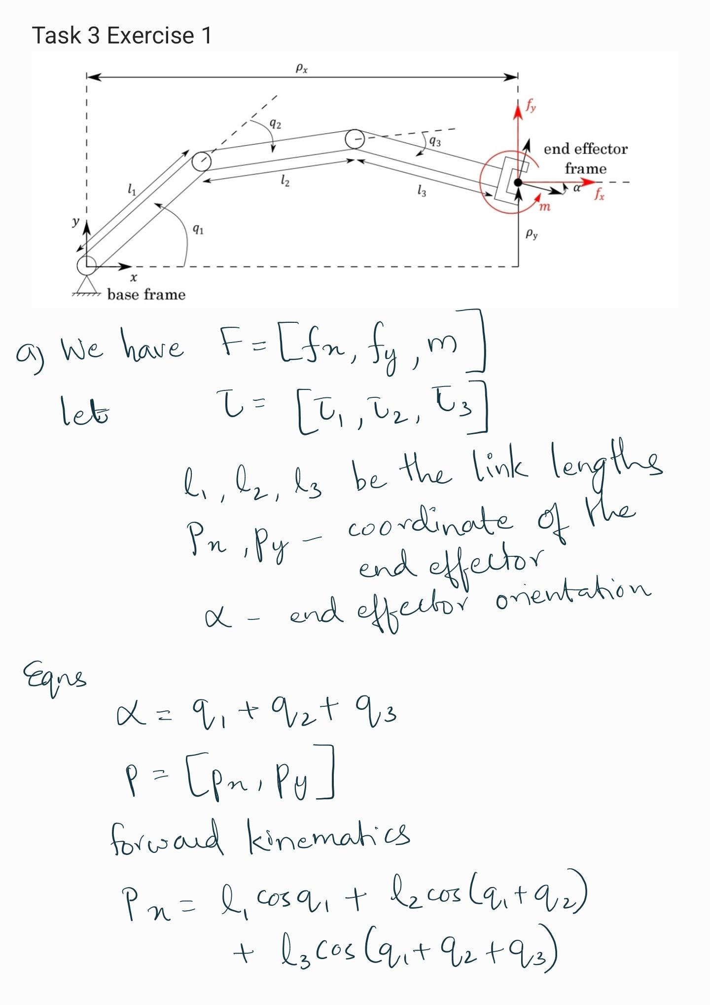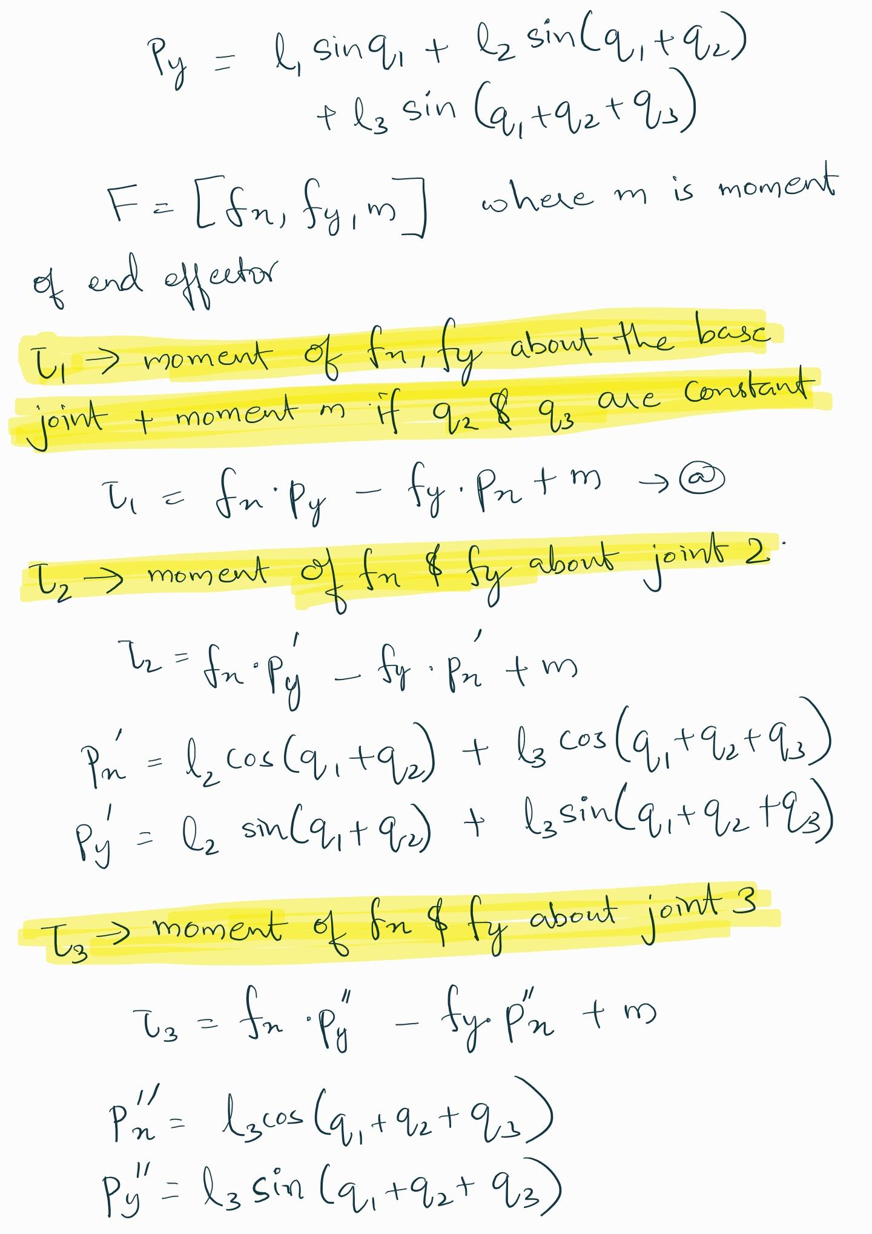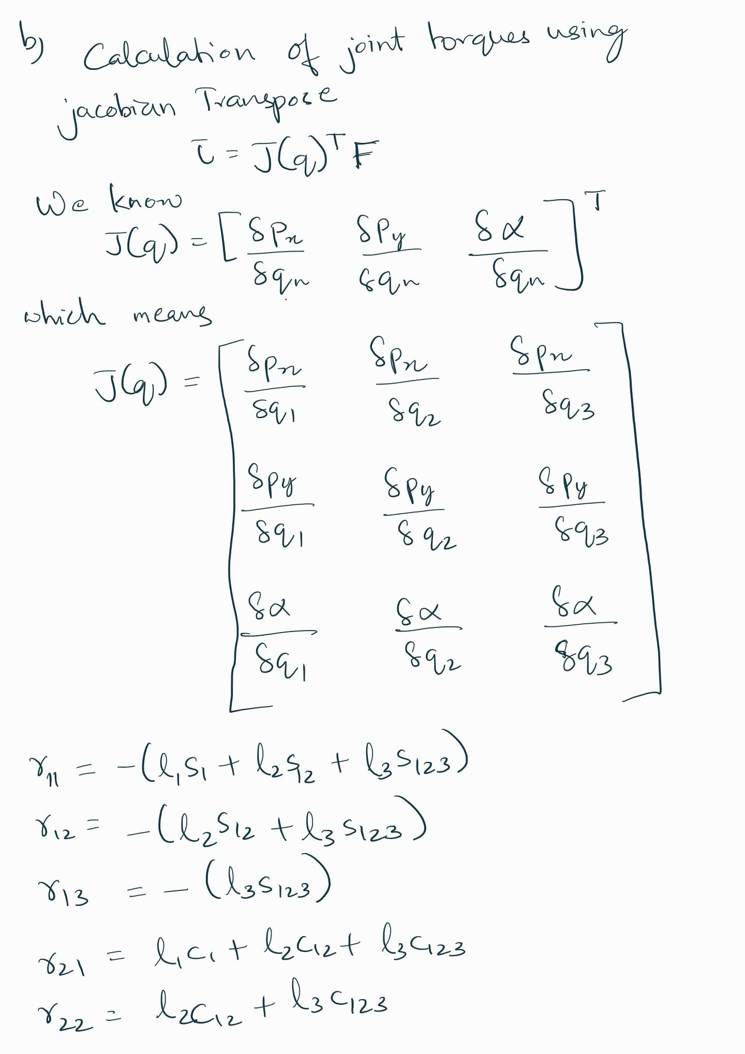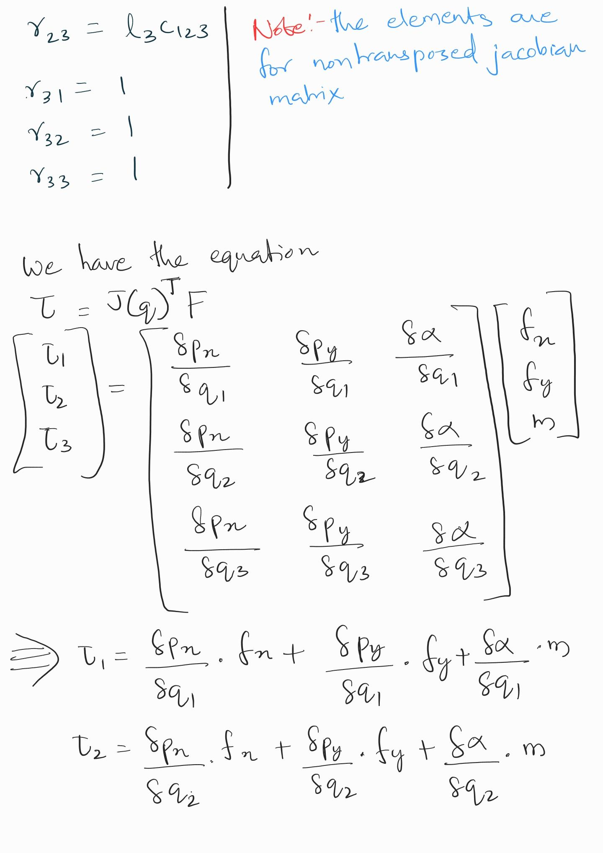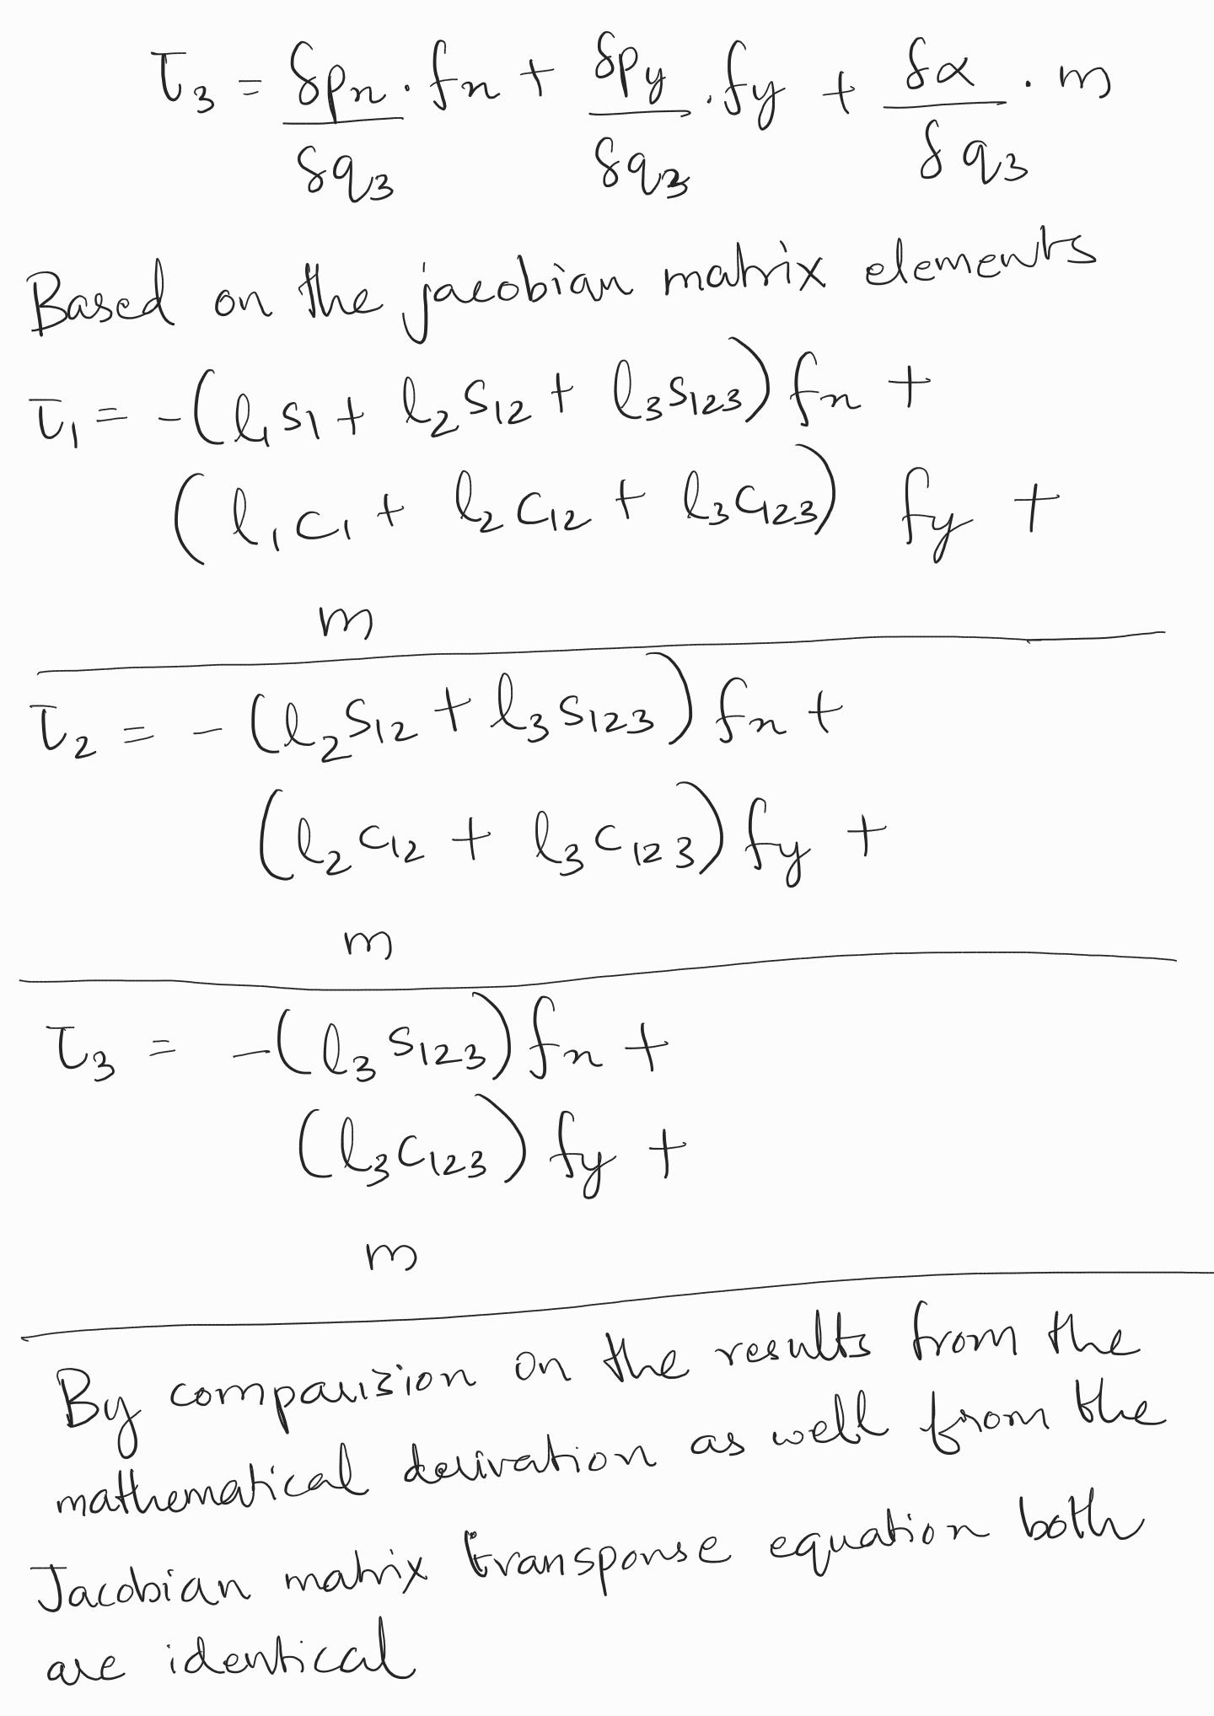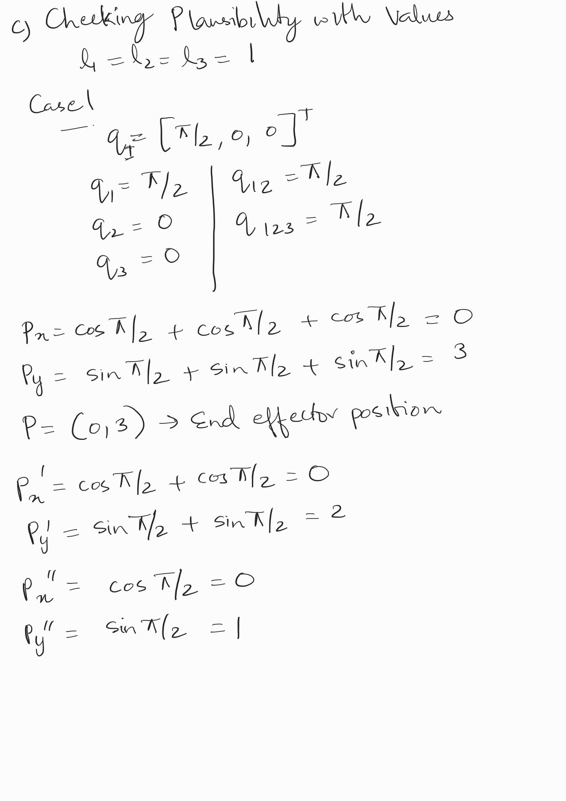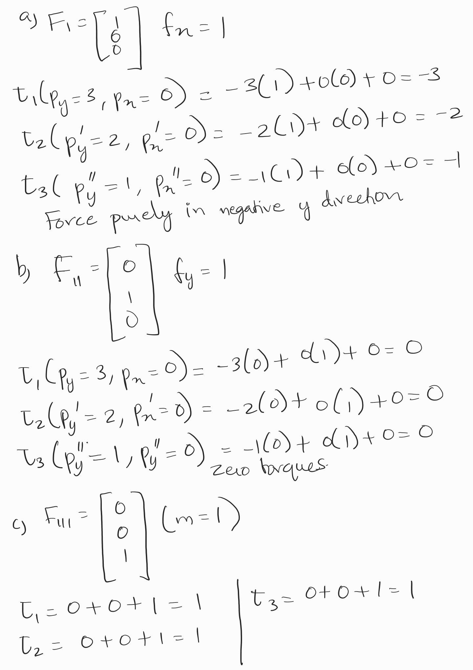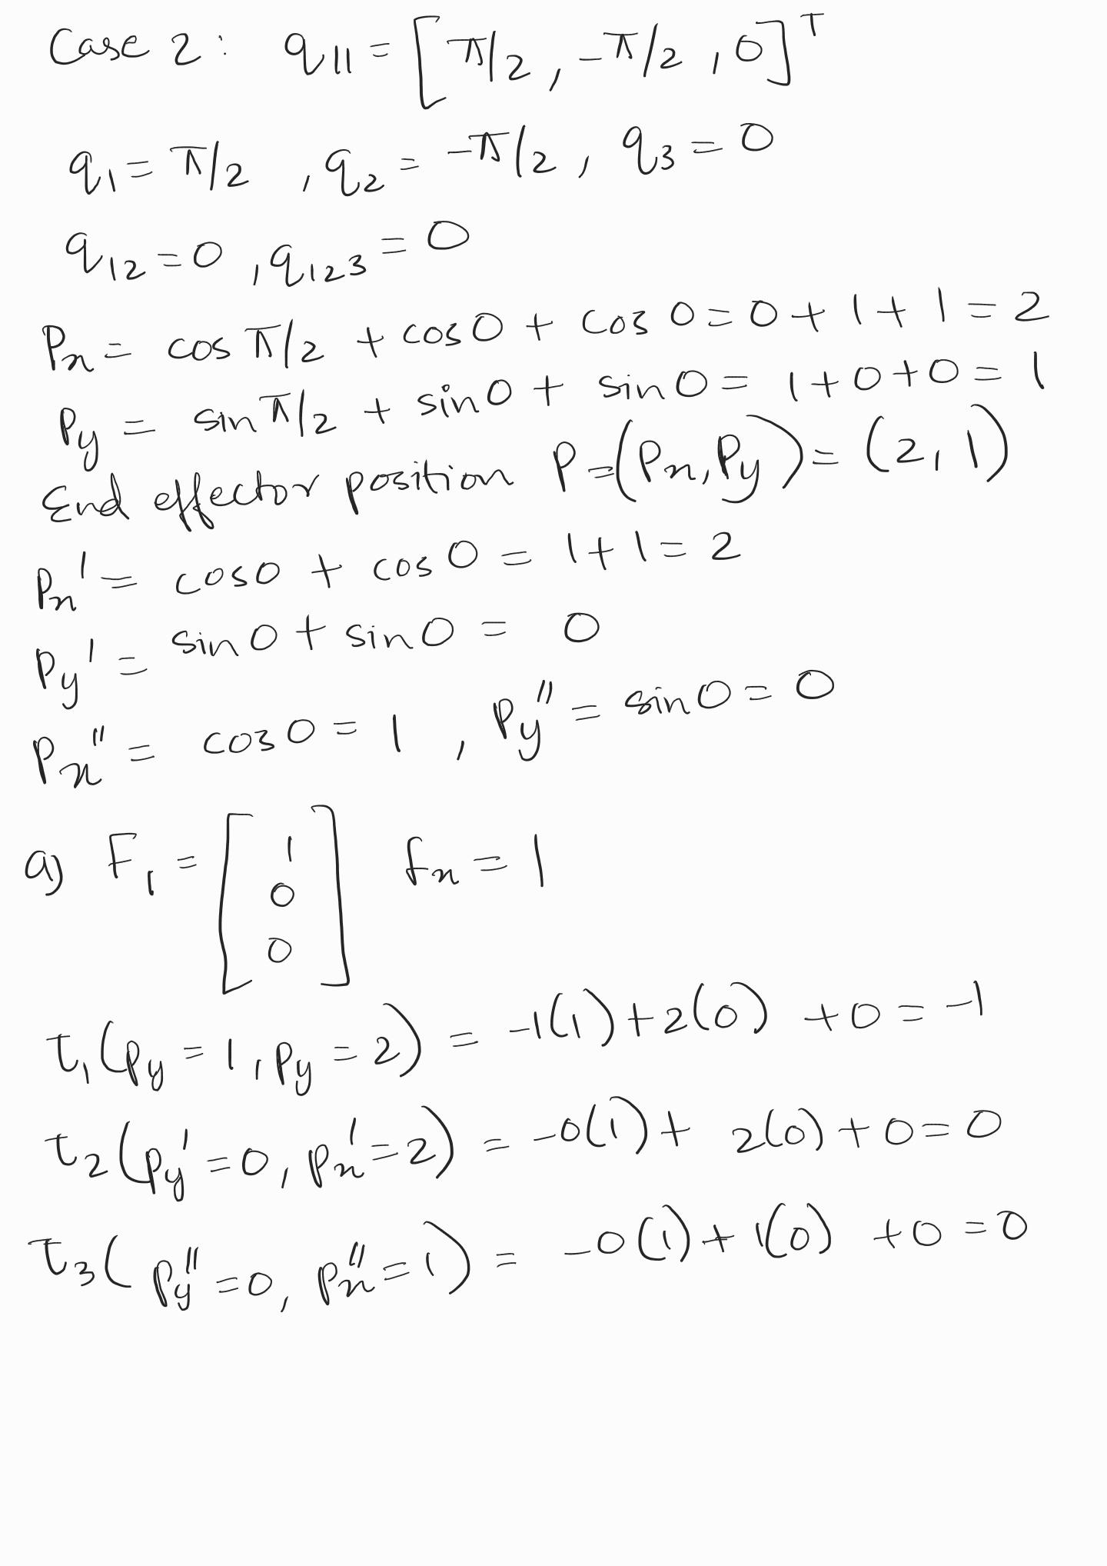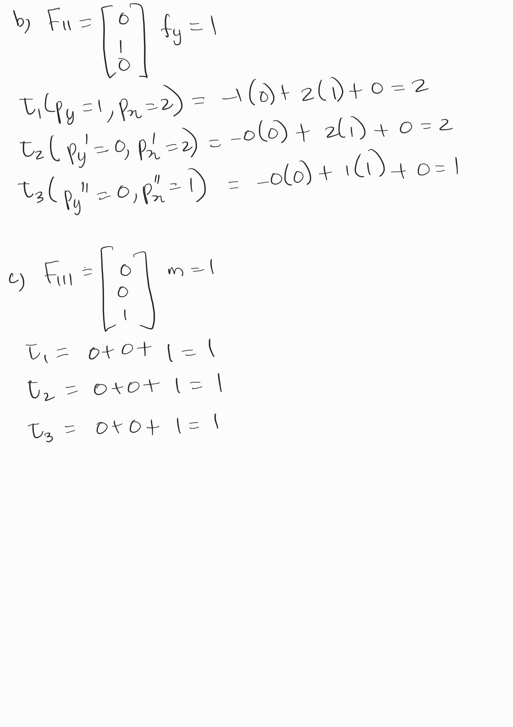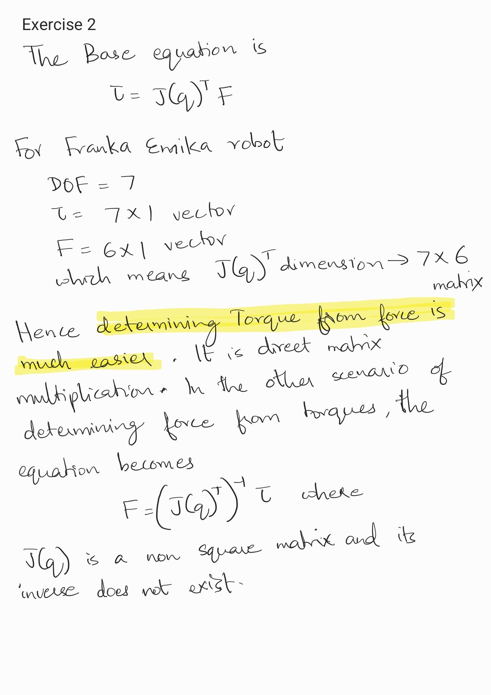
Exercise 3
The main disadvantage of using Publishers and Subscribers (Topics) for all forms of communication is that they work in a continuous and asynchronous manner.
- Continuous Data Stream: Publishers send data continuously at a defined rate. This is inefficient if the data only needs to be updated or transferred once, or only when a specific event occurs.
- No Confirmation/Feedback: The communication is asynchronous and one-way (fire-and-forget). The Publisher does not know if the Subscriber actually received the message or if the processing was completed successfully. There is no automatic acknowledgment or response.
- Resource Overhead: Continuously sending data, even when the value hasn't changed or the information isn't immediately needed, consumes unnecessary computational resources and bandwidth.
For applications like triggering a start/stop command or requesting an expensive calculation, continuous broadcasting is wasteful.
Alternative Communication Possibility is ROS Services (Request-Response) or ROS Actions
- Request-Response Paradigm: ROS Services use a synchronous, two-way communication model. A Client sends a request message to a Server (Node), and the Server processes it and returns a single response message.
- One-Time Information: This is ideal for transmitting one-time information at a single point in time.
- Confirmation of Completion: It is typically used for processes that run very quickly or that require a confirmation of completion before the calling instance continues.

Exercise 4
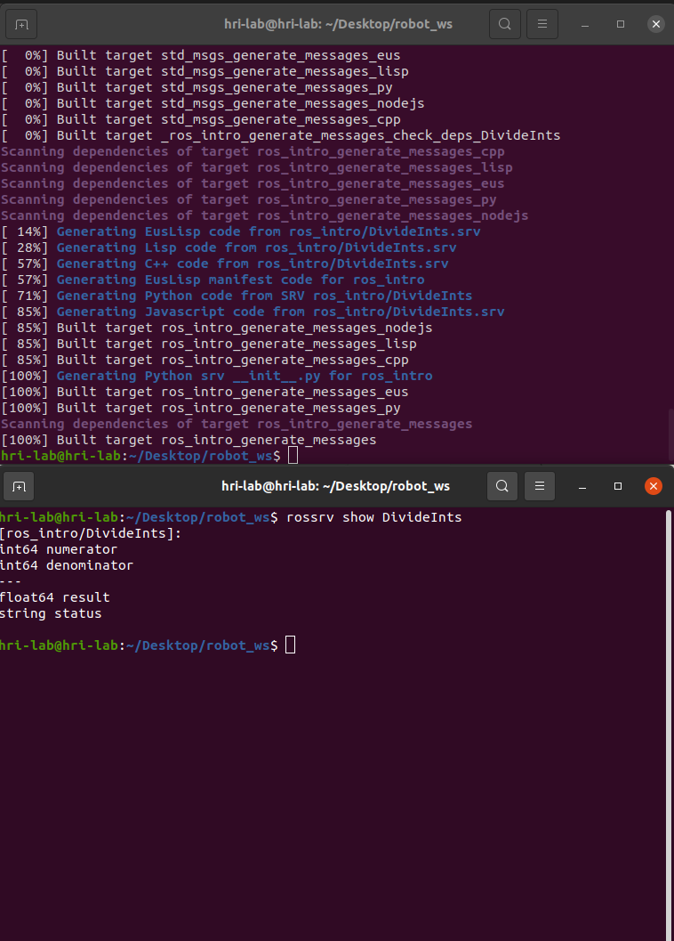
Exercise 5
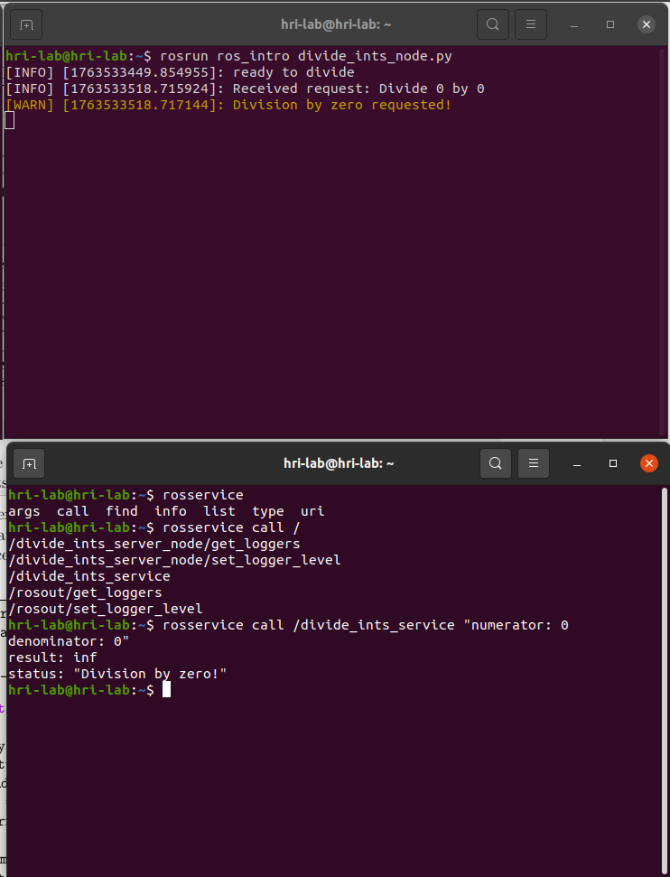

Exercise 6

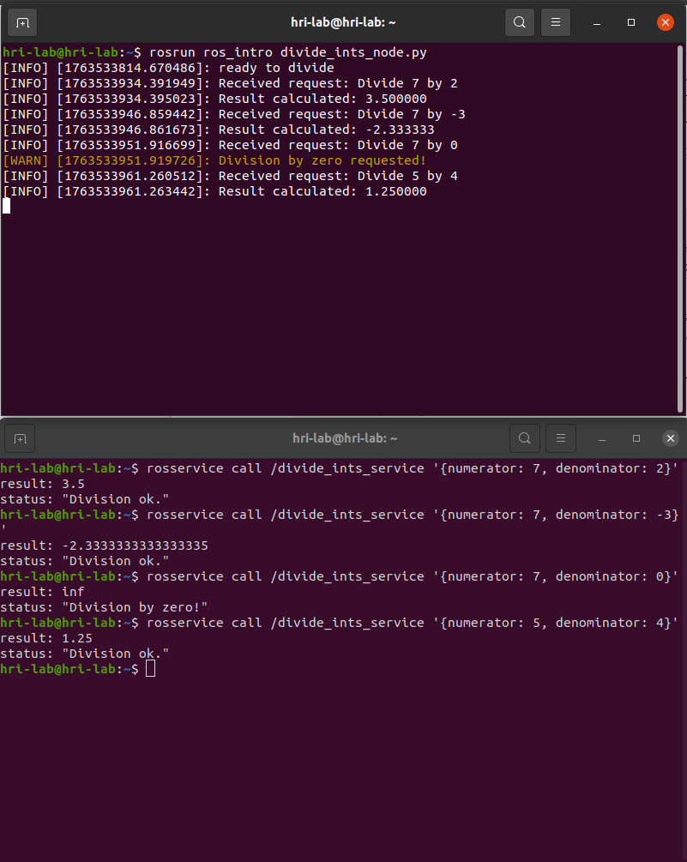
Exercise 7
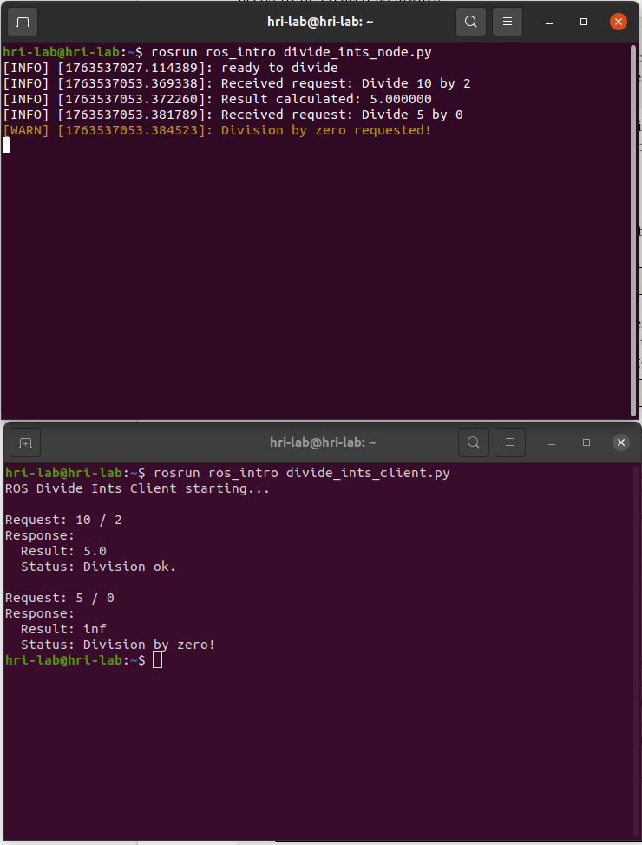
Exercise 8

On experimentation.

Exercise 9

Undergone the scientific paper review and noted down important concepts

